COAL LAB 9
FAIQA RAFIQUE
SAP ID:72027
TASK 1
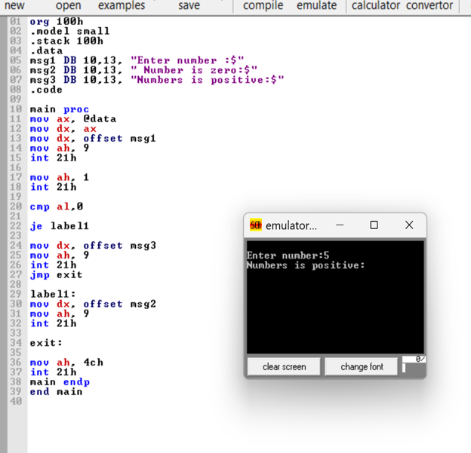
TASK 2
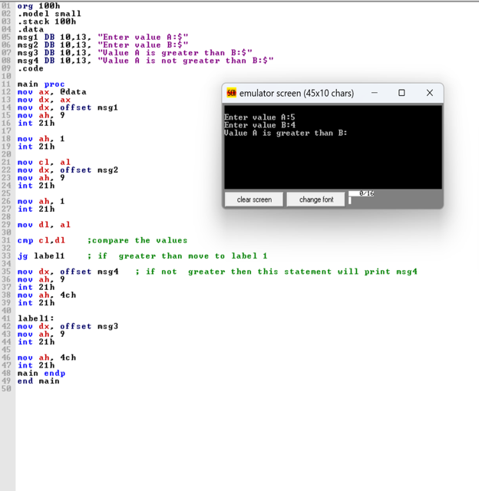
TASK 3
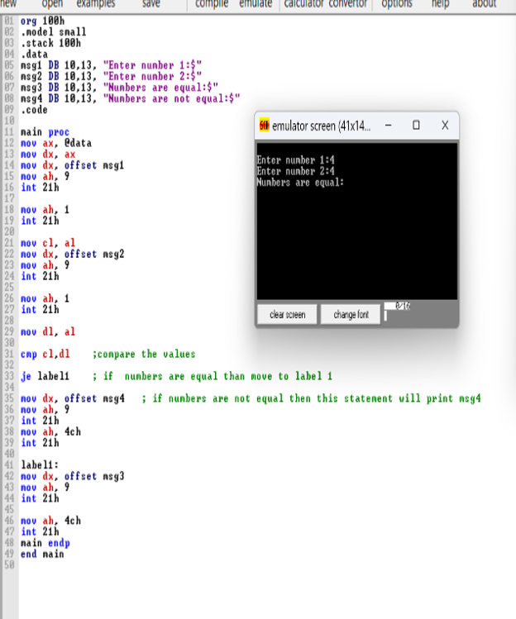
TASK 4
Difference Between Unconditional Jump and Conditional Jump?
In Assembly Language, jump instructions are used to change the normal flow of a program.
1. Unconditional Jump
An unconditional jump transfers program control to another location without checking any condition.
- Instruction used: JMP
- It always jumps to the given label.
- It does not depend on comparison flags.
Example:
.MODEL SMALL
.STACK 100H
.CODE
MAIN PROC
MOV AX, 5
JMP LABEL1
MOV AX, 10
LABEL1:
MOV BX, 20
MOV AH, 4CH
INT 21H
MAIN ENDP
END MAIN

2. Conditional Jump
A conditional jump transfers program control to another location only when a specified condition is true.
- It is commonly used with CMP.
- It checks CPU flags to decide whether to jump.
- If the condition is false, the next instruction executes normally.
Example:
.MODEL SMALL
.STACK 100H
.CODE
MAIN PROC
MOV AL, 5
CMP AL, 5
JE LABEL1
MOV BL, 0
JMP EXIT
LABEL1:
MOV BL, 1
EXIT:
MOV AH, 4CH
INT 21H
MAIN ENDP
END MAIN

